DRAFT FINAL

ExxonMobil Technology and Engineering

Water Crossing Program

**Appendix H:**

Vortex-Induced Vibration Evaluation Guidelines

WCP Technical User Guide, Appendix Support Material

Version 1 | March 2025

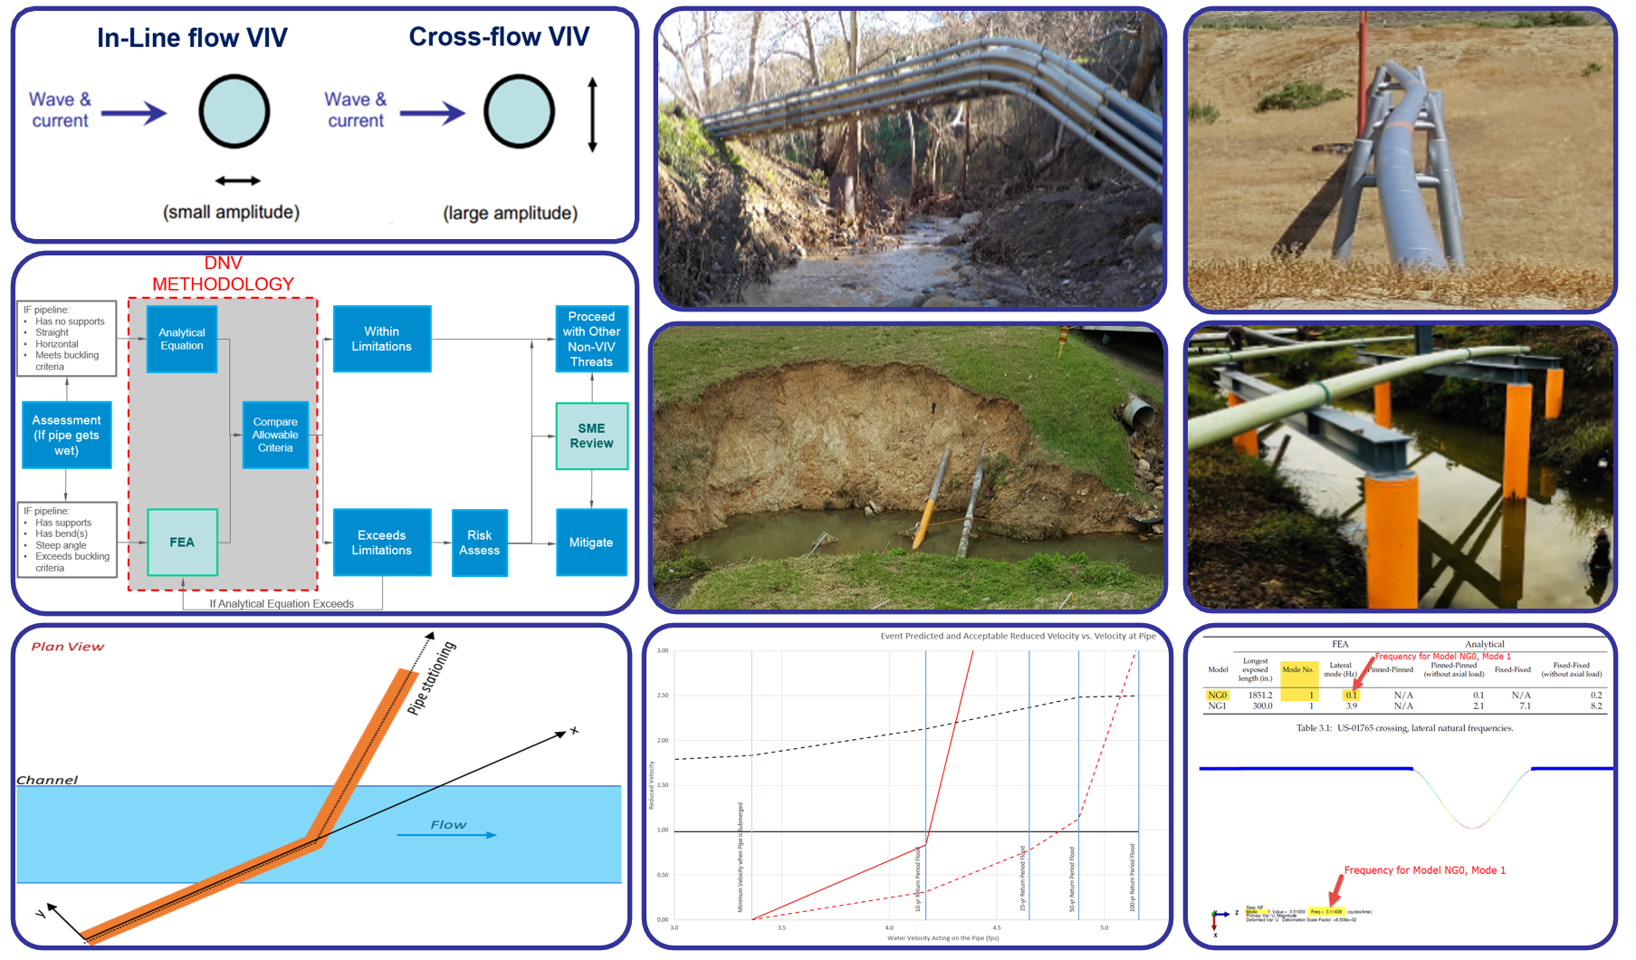

Contents

Contents ii

Introduction 1

1 WCP Workflow 2

2 General Description of VIV 3

3 Basis of Analysis 3

4 General Evaluation Methodology 5

5 Evaluating the Applicability of VIV 6

6 VIV Evaluation Methods 6

7 VIV Evaluation Tools 8

7.1 VIV Template Inputs 8

7.1.1 Analytical Equation Execution 11

7.1.2 Finite Element Analysis Execution 12

7.2 FEA Cross-Section Tool (FEA Inputs) 19

7.3 WCP Protocol 23

8 Risk Assessment Inputs 25

9 Mitigation Options 26

Acronyms and Abbreviations 28

External References 29

Tables

Table 7‑1. Example RSST Phase III Report Top of Pipe Velocity Estimates 11

Figures

Figure 1‑1. General Water Crossing Program Workflow (Stages 1 – 7) 2

Figure 3‑1. Inline And Crossflow Pipe Vibration Visual Representation 3

Figure 3‑2. Vibration Modes 4

Figure 4‑1. VIV Assessment Process Overview (Stage 4 -7) 5

Figure 6‑1. Supported Spans 7

Figure 6‑2. Spans With Bends 7

Figure 6‑3. Span With Steep Angles 7

Figure 6‑4. Span Subject to Buckling 7

Figure 7‑1. Temperature Example 9

Figure 7‑2. Pink Errors Exists, Limitations Reached, FEA Required 13

Figure 7‑3. Pink Errors Exists, Limitations Reached, FEA Not Required 13

Figure 7‑4. Pink Errors Exists, Limitations Not Reached, FEA Not Required 14

Figure 7‑5. How To Start Excel in Safe Mode 14

Figure 7‑6. Crossflow Direction Verification Example 15

Figure 7‑7. Inline Direction Verification Example 15

Figure 7‑8. Frequency Verification Example 15

Figure 7‑9. Participation Factor Verification Example 16

Figure 7‑10. Mode Shape Verification Example 17

Figure 7‑11. Mode Shape Verification Example, continued 18

Figure 7‑12. Displacements at mid-span for exposed segment 3 18

Figure 7‑13. Displacements at mid-span for exposed segment 4 18

Figure 7‑14. Mode Shape Verification Example, continued 19

Figure 7‑15. Initial tabs of FEA Cross-Section Tool (FEA Inputs) 19

Figure 7‑16. X and Y Coordinates for Straight Pipelines 20

Figure 7‑17. X and Y Coordinates for Non-Straight Pipelines 20

Figure 7‑18. Scenario 0 may be existing supports, Scenario 1 may be with restraints 21

Figure 7‑19. Scoured Cross Section in RSST 22

Figure 7‑20. Final FEA Inputs Columns 22

Figure 7‑21. Event Reduced Velocity Graph 24

Figure 8‑1. Multiple Pipelines on Pipe Supports – Shielding Case 25

Figure 9‑1. Horizontally Unrestrained Pipelines on Pipe Supports 26

Figure 9‑2. Pressure vs. Frequency Plot Example 27

Revision Record

|  |  |  |  |
| --- | --- | --- | --- |
| Revision No. | Date Issued | Reviewed By | Description |
| Draft 0 | 08.2018 | EMPCo | Launched vortex-induced vibration evaluation procedure consistent with DNV-RP-F105 *[4]* and to satisfy ASME B31.4 *[2]*, *[3]* requirements where the vortex-induced vibration avoidance criteria should be met. Also consistent with API 1133 references/guidelines *[1]*. |
| Draft 1.0 | 05.2022 | EMPCo | Enhanced the procedure, include references to new developed tools and templates |
| 1 | 03.2025 | EMTech/EMPCo  Aeman Javed  Svetlana Shafrova | Enhanced the procedure and initial release for Global XOM use (applicable to both Upstream and Downstream Sites/Assets). |
|  |  |  |  |

Introduction

This *Vortex-Induced Vibration (VIV) Evaluation Guidelines* is a supplement (*Appendix H*) to the *Water Crossing Program (WCP)* [*Technical User Guide*](https://teamwork4.exxonmobil.com/sites/GlobalWCP/Shared%20Documents/WCP%20Toolkit/WCP%20%20Manuals%20and%20Guidelines/WCP%20Technical%20User%20Guide). It describes how to evaluate pipeline water crossings for potential vulnerability to VIV using WCP methodology and tools as part of engineering assessments.

The WCP aims to identify locations where natural forces could potentially impact the integrity of a pipeline due to either hydrotechnical or geotechnical forces at or in close proximity to waterbodies (i.e., pipeline water crossings, adjacent river bends, and later encroachment sites), and provides guidance for temporary and/or permanent mitigative measures and monitoring activities.

The general overview of the WCP process and workflow stages are described in [*WCP Manual*](https://teamwork4.exxonmobil.com/sites/GlobalWCP/Shared%20Documents/WCP%20Toolkit/WCP%20%20Manuals%20and%20Guidelines/WCP%20Manual)*.* This *VIV Evaluation Guidelines* solely focuses on describing procedures for evaluating VIV threat of concern. It assumes water Crossing Engineers (WCEs) are familiar with the WCP as described in the [*WCP Manual*](https://teamwork4.exxonmobil.com/sites/GlobalWCP/Shared%20Documents/WCP%20Toolkit/WCP%20%20Manuals%20and%20Guidelines/WCP%20Manual)and [*WCP Technical User Guide*](https://teamwork4.exxonmobil.com/sites/GlobalWCP/Shared%20Documents/WCP%20Toolkit/WCP%20%20Manuals%20and%20Guidelines/WCP%20Technical%20User%20Guide).

Note that analyses associated with the WCP and assessing pipeline vulnerability to natural forces are complex. WCP tools are not intended to be comprehensive engineering analyses on their own. This *VIV Evaluation Guidelines* is intended as a reference document and is not intended to be all-inclusive. It is intended to introduce technical concepts and tools but is not meant to supersede engineering best practices or hydrologic and hydraulic textbooks or technical documents. Professional engineering judgment in combination with insights from Operations/Sites are essential to successful estimation of present and possible future natural force threats to pipeline integrity at water crossings. This *VIV Evaluation Guidelines* provides guidance based on the best-known information and practices at the time and should be reviewed and updated as needed to maintain accuracy.

Neither ExxonMobil Corporation (XOM) nor any of their contractors, subcontractors, or their employees, makes any warranty, express or implied, or assumes any legal liability or responsibility for the technical accuracy or completeness of the processes and methods disclosed in this guide.

# WCP Workflow

The WCP workflow (*Figure 1‑1*) is designed to (1) identify and manage hydrotechnical or/and geotechnical threats; (2) identify, monitor, and manage changes over time; and (3) comply with regulatory and industry standards requirements and recommendations as well as align with best practices.

Figure 1‑1. General Water Crossing Program Workflow (Stages 1 – 7)



The VIV Evaluation Guidelines described herein will be implemented as part of WCP **Stage 4 Engineering Assessment** and/or to support risk assessment discussions, monitoring/ mitigation design selection during WCP **Stages 5-7** as applicable.

# General Description of VIV

VIV is the vibration of a pipeline caused by fluid flowing around the pipe. When water currents flow across a pipeline, vortices occur downstream from the pipe. These vortices are caused by flow turbulence and instability behind the pipe. Vortex shedding causes a periodic change in the net hydrodynamic pressure on the pipe, which may cause a pipe span to vibrate. Vortices shed in the wake of pipe can result in oscillating forces on the pipe both in the direction of flow - ***Inline VIV*** and in a direction perpendicular to the fluid flow - **Crossflow VIV** (see *Figure 3‑1*). If the frequency of vortex shedding is similar to the natural frequency vibration of the pipe, then the vortex shedding can “lock in” and cause amplified pipe motion. The resulting stresses on the pipe can result in fatigue damage, potentially leading to failure and loss of containment.

# Basis of Analysis

Det Norske Veritas Recommended Practice F-105 Free Spanning Pipelines (DNV-RP-F105)*[4]* is an industry standard for VIV evaluation. It provides avoidance criteria for inline VIV and crossflow VIV based on a maximum allowable reduced velocity (Vr), which translates to a minimum allowable natural frequency of the pipeline.

* Inline VIV is generally small amplitude vibration that may not add large stress and may have longer fatigue life available (*Figure 3‑1*). The vibration of inline VIV is back and forth in the direction of the water flow around the pipe (generally horizontal vibration for inland water crossings).
* Crossflow VIV is associated with larger amplitude vibration, although it can also occur at low amplitudes (*Figure* *3‑1*). This larger amplitude can fatigue a pipeline very quickly (seconds to hours) and has caused several loss of containment incidents in industry. Crossflow VIV occurs when the pipeline vibrates across the flow of water around the pipe (generally vertical vibration for inland water crossings).

Figure 3‑1. Inline And Crossflow Pipe Vibration Visual Representation

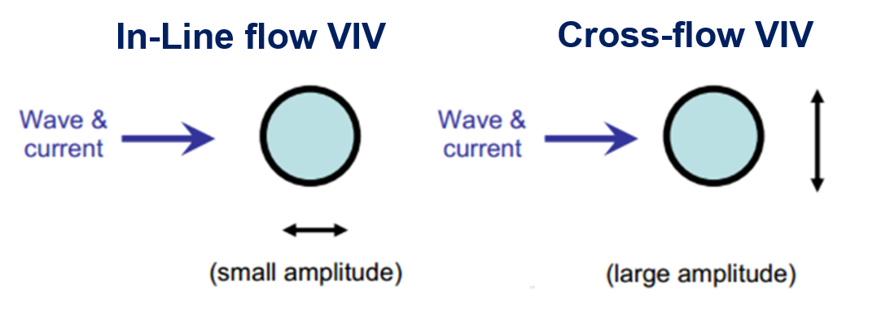

The fatigue life remaining at a pipeline water crossing may not be known. Because of this, crossings are evaluated for DNV-RP-F105 VIV avoidance criteria *[4]*. Crossings that exceed avoidance criteria are assumed to vibrate and experience vibratory forces and fatigue. The WCP evaluates the potential for VIV up to the 1%-annual exceedance chance flood event by comparing the allowable natural frequency at each return period flood event to the predicted natural frequency of the pipe – calculated either analytically or through Finite Element Analysis (FEA) performed through computer modeling – at various return period flood events and over time as banks (slopes) erode or channels degrade. The natural frequencies are reported in reduced velocity, a way of normalizing vibration frequencies at various water velocities and outside diameter (OD) sizes for the pipe and its coating.   
API RP 1133 *[1]* refers to DNV-RP-F105 *[4]* for VIV analysis.

As mentioned above the VIV is a function of natural frequency and reported in reduced velocity. As the flow velocity is increased or decreased so that the vortex shedding frequency, $f_{s}$, approaches the natural frequency of an elastic structure (pipeline) so that the vortex shedding frequency suddenly locks onto the structure frequency $f_{n}$ as shown by equations *Equation 3‑1* and *Equation 3‑2* below:

|  |  |  |
| --- | --- | --- |
|  | ${f_{n}\sim f}_{s}=\frac{S_{t}U}{D}$ or $\frac{U}{f_{n}D}\sim \frac{U}{f_{s}D}=\frac{1}{S_{t}} \sim 5$ | *Equation 3‑1* |
|  | $V_{r}=\frac{U}{f_{n}D}$ and $\frac{f_{S}}{f_{n}}=S_{t}V_{r}$ | *Equation 3‑2* |

where

$f_{n}$ natural frequency of the oscillation body (pipeline)

$f_{s}$ vortex shedding frequency

*U* free stream flow velocity normal to body (pipeline)

*D* diameter of oscillation body (pipeline OD)

$V_{r}$ Reduced Velocity

$S_{t}$ Strouhal Number

Each vibration pattern is called a mode. For each of these modes, there will be locations on the pipe with maximum displacement (displacement antinodes) and locations which do not move at all (displacement nodes). The vibration pattern modes 1- 5 are shown on *Figure 3‑2.* The analytical approach is used to access mode 1 pattern only, while the FEA modeling covers Modes 1 through 12.

Figure 3‑2. Vibration Modes

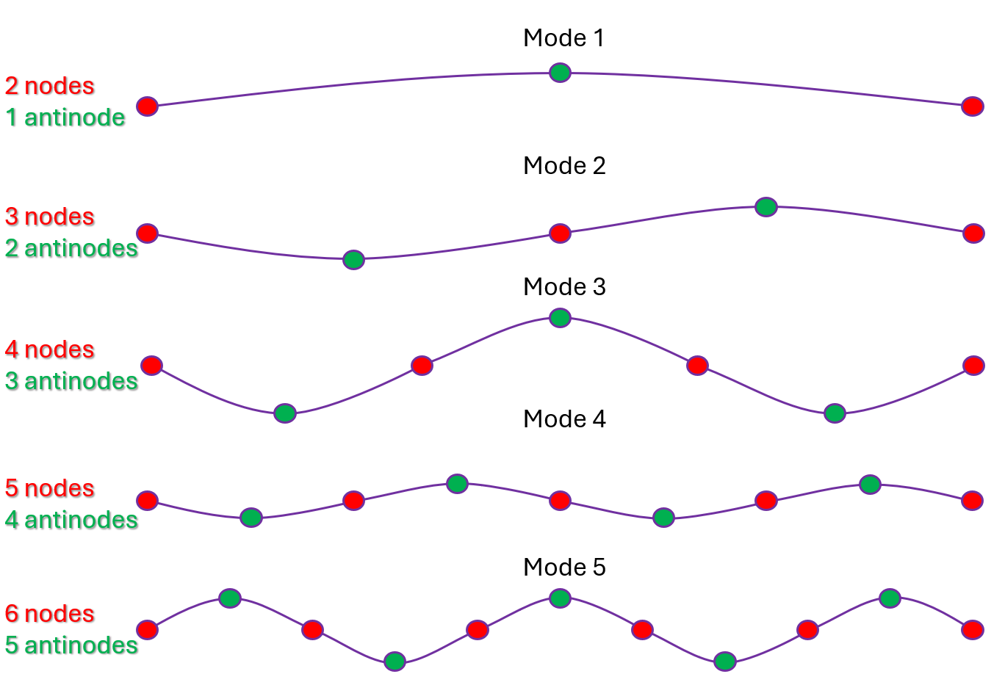

As part of the WCP, if a crossing is predicted to exceed the allowable natural frequency, then performing risk screening and/or Scenario Based Risk Assessment (SBRA) is recommended. When mitigation is warranted, the recommended/selected mitigation design is validated using the same methodology described above. Use the [*WCP Manual*](https://teamwork4.exxonmobil.com/sites/GlobalWCP/Shared%20Documents/WCP%20Toolkit/WCP%20%20Manuals%20and%20Guidelines/WCP%20Manual)and [*WCP Technical User Guide*](https://teamwork4.exxonmobil.com/sites/GlobalWCP/Shared%20Documents/WCP%20Toolkit/WCP%20%20Manuals%20and%20Guidelines/WCP%20Technical%20User%20Guide) for more information.

# General Evaluation Methodology

VIV analysis/evaluation is performed during engineering assessment (WCP Stage 4) of as follows:

* Determine whether the pipeline is submerged/exposed to water with a gap beneath the pipe through the detailed assessment process
* Determine the applicability of using the analytical equation for estimating the natural frequency of the pipe.
* Determine the natural frequency using the analytical equation or FEA
* Compare the calculated natural frequency (or reduced velocity) to the allowable frequency. If the crossing exceeds limitations using the analytical equation and, based on risk screening results, may result in potential highlighted risk (e.g., HC1/HC2 or CAT1/CAT2), then the natural frequency should be calculated using the FEA model to reduce the conservatism and provide a more accurate estimate
* If the calculated natural frequency exceeds the allowable natural frequency, then a risk assessment is recommended to perform per Global Manufacturing OIMS Practice (GMOP) 2.1 in coordination with the Safety, Security, Health, and Environment (SSHE) group or/and risk advisors (WCP Stage 5)
* If the risk assessment outcome warrants a mitigation project (WCP Stage 7), then additional FEA modeling may be required to verify the mitigation effectiveness. The crossing may also require additional monitoring (WCP Stage 6) and High Water Action Plan (HWAP) should be developed if practically available.
* When mitigation project is completed, then the [EDD 2015](https://teamwork4.exxonmobil.com/sites/GlobalWCP/Shared%20Documents/WCP%20Toolkit/WCP%20Tools%20and%20Forms/EDD%202015) riverine screening or/and engineering assessment, monitoring type, frequency, HWAP status should updated based on mitigation as-builts data.
* If risk assessment is not needed, or if a mitigation project is not warranted, then the crossing will require schedule or/and trigger monitoring (WCP Stage 6) leveraging the [Schedule Monitoring Guidelines](https://ishareteam2.na.xom.com/sites/EMDC4174/PipelinesAndRisers/Global%20Water%20Crossing%20Program/WCP%20Tools%20and%20Forms/Schedule%20Monitoring%20Guidelines) or/and recommendations from relevant Subject Matter Experts (SMEs).

The flow chart on *Figure 4‑1* below illustrates the general process, more details are given further in *Sections 5-9*.

Figure 4‑1. VIV Assessment Process Overview (Stage 4 -7)

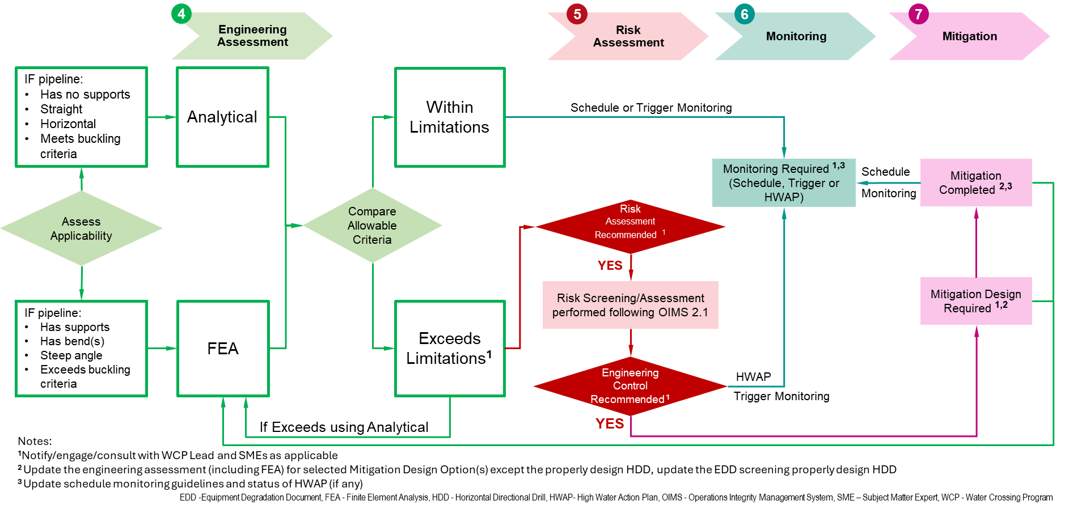

# Evaluating the Applicability of VIV

VIV can only occur when a pipeline is partially or fully submerged and has water flowing past the pipeline body on two sides. This could occur if a pipeline is exposed at the bottom of a channel and a gap forms between the pipeline bottom and the channel bed (for conventionally laid exposed pipe), or if water surface elevation is higher than the top of the pipe (for pipes with intentional spans with or without pipe supports). Note that when a pipeline is predicted to be exposed but not unsupported, WCEs should keep in mind the limitations of scour calculations, including lack of local scour predicted from an exposed pipe.

For pipelines designed to span above a channel, such as when elevated on pipe supports, the pipe would have to be submerged to cause VIV. There is currently no definitive industry guidance available to indicate the length of pipeline that would need to be submerged in order to potentially cause VIV; therefore, each situation should be considered on a case-by-case basis and engineering judgement should be applied to determine a final conclusion. WCEs should also consider consulting the SMEs for guidance. Typical conditions of partially wet/submerged pipeline include:

* Pipe on overbend;
* Pipe on supports and not perfectly horizontal within the channel;
* Pipe exposed and not horizontal within the channel (steep angle); and
* Flood flow water surface elevation high enough to wet but not submerge the pipe.

# VIV Evaluation Methods

There are two ways to evaluate whether a pipeline will experience VIV: analytical equations or natural frequency estimations from FEA. Analytical equations can only be used if the criteria listed below are met. Otherwise, FEA must be used to determine the pipeline natural frequency.

Analytical equations can only be used if the following criteria are met:

* + The pipeline exposure is a single, unsupported span (no pipe supports).
  + The pipeline exposure has no major bends (slight overbend may be alright).
  + The pipeline exposure is not any steeper than 10 to 15 degrees along the profile.
  + The pipeline meets buckling criteria.

Analytical equations should NOT be used for supported spans, spans with bends, spans with steep angles, or spans subject to buckling (see examples on *Figure 6‑1* through *Figure 6‑4*).

|  |  |
| --- | --- |
| Figure 6‑1. Supported Spans  Supported Spans require FEA | Figure 6‑2. Spans With Bends  Spans with bends require FEA |
| Figure 6‑3. Span With Steep Angles  Spans with steep angles require FEA | Figure 6‑4. Span Subject to Buckling  Spans subject to buckling require FEA |

For pipelines that meet the above criteria, the Goal Seek function in Microsoft Excel may be attempted to solve for an allowable unsupported span length (USL) to avoid VIV. However, this output may not guarantee that the analytical equation is applicable; see the following limitation cases:

* The allowable unsupported span of the pipeline is not influenced by bar buckling (Seff/Pcr < -0.5). The pipeline is NOT exceeding the buckling criteria. This happens more often when pipes are installed in winter in very cold temperatures. This can cause the pipe to “snake” back and forth (see *Figure 6‑4*).
* The allowable unsupported span of the pipeline must not exceed a length to diameter ratio greater than 140.
* The allowable unsupported span of the pipeline does not deflect more than 2.5 times the diameter of the pipe under gravity or buoyancy forces.

Descriptions of how to identify limitation cases by utilizing the VIV template tool are included in the following section.

For any pipeline crossing that does not meet the above criteria, FEA is required to determine the pipeline natural frequency. If the pipeline exceeds the limitations for the VIV scenario and risk assessment is recommended based on initial screening results, then the FEA evaluation should be conducted to support risk assessment discussion and justify the mitigation project (if needed).

# VIV Evaluation Tools

The following [WCP tools](https://teamwork4.exxonmobil.com/sites/GlobalWCP/Shared%20Documents/WCP%20Toolkit/WCP%20Tools%20and%20Forms) should be used for VIV assessment:

* Rapid Scour Screening Tool (RSST) / Scour Evaluation – Used to estimate span length, velocity at pipe, and gap below the pipe.
* VIV Template – Used to calculate allowable spans using the analytical equation, input FEA data if applicable, and populate inputs for the WCP Protocol tool.
* FEA Cross-Section Tool Inputs – Used to transfer data to FEA models.
* WCP Protocol – Used to visually compare calculated vs. allowable reduced velocity; includes monitoring schedule.

## VIV Template Inputs

The data input tab (“DNV RPF105”) includes six types of cells:

* Orange Cells: WCE inputs based on data available. These may come from pipeline properties, RSST outputs, soil data, or regional temperature differences. These inputs should be consistent throughout all WCE tools for a specific crossing.
* Green Cells: Inputs that may require SME guidance or careful WCE consideration before making changes to prepopulated values. Consult comments in the cell if applicable.
* Blue Cells: WCE decisions based on specific scope of tool.
* Yellow Cells: Cells related to the Goal Seek function.
* Gray Cells: Cells with embedded calculations that require no additional changes by the WCE.
* Pink Cells: Gray cells that are flagged (by conditional formatting to make them pink) for potential issues with using the analytical method to determine allowable USL to avoid VIV.

Cells specific to the VIV Template (i.e., not included in the RSST or WCP Protocol) include the following:

* “**Δ Temperature from Lay**”: This represents the temperature difference of the pipe from the time of installation to conditions during a flood event. Because the WCE generally does not know the temperature at installation, a conservative range of the HIGHEST monthly average HIGH temperature minus the LOWEST monthly average HIGH temperature can be used. If a pipeline is known to have been installed during winter, then the LOWEST monthly average HIGH temperature minus the HIGHEST monthly average HIGH temperature may be used. See the example below (*Figure 7‑1*).

|  |  |
| --- | --- |
| Figure 7‑1. Temperature Example  A screenshot of a calendar  Description automatically generatedSource: Google Search *[5]* | Unknown installation of pipe in Houston, TX: $$91℉-60℉=31℉$$ Pipe known to be installed in winter in Houston, TX $$60℉-91℉=-31℉$$ The temperature data can come from sites such as:   * [USClimateData.com](https://www.usclimatedata.com/) *[6]* using a nearby town/city (Houston). * Google Maps or Google Earth by searching a nearby town/city with climate *[5]* (Houston).   Data sources used should be captured and saved to the “Screengrab” tab (see *Figure 7‑1*).  This estimate should be reasonable, if not conservative, for pipeline spans exposed in the air and should be very conservative for pipes that are buried and become exposed during scour. |

* “**Concrete Coating w.t.**”: This represents the wall thickness (w.t.) of concrete coating around the pipe. Concrete coating increases the weight of the pipeline while it vibrates. Concrete, when in good condition, can also provide stability and resists vibration. Assumptions about concrete are made in the following green cells that the WCE may carefully consider and/or discuss with the SME.
  + “Coating E”: The elasticity of the concrete coating on the pipeline is generally not known by the WCE. Assumption value is prepopulated as 4.5x106 pounds per square inch. Consult a structural SME if necessary.
  + “CSF”: The Concrete Stiffness Factor (CSF) is the extra resistance to vibration provided by concrete coating. This factor is calculated, but the WCE may override the value to 0 (zero) if the condition of the concrete coating is cracked or unknown (conservative). Cracked concrete may not provide any additional stiffness.
  + “Structural Damping”: A vibrating structure has some internal damping that reduces vibration. This box assumes concrete in good condition provides extra damping. If the concrete is known to be cracked or the condition is unknown (conservative), the WCE may override the value to 0.005.
  + “Surface Roughness”: The ability to form vortices is a function of the outermost coating. For most smooth coatings such as epoxies or wraps, assume “Steel Painted”. If it is uncoated steel, assume “Steel Un-coated”. If concrete coated, assume “Concrete”.
* “**Corrosion Coating**”: This input is based on the layer of coating outside the pipe that may provide additional friction. The WCE should assume “PP/PE” for polypropylene/polyethylene unless asphalt is known to be used.
* “**Soil Density**”: This describes the general soil type. This should be conservatively estimated as Soft Clay or Medium Sand based on predominant soil type. Other values can be used at the WCE’s discretion if more soil data is available.
* “**Safety Class**”: This is a safety factor classification based on risk. Because these are used to create a risk assessment, we assume the lowest safety class and apply consequences during an XOM risk assessment separately.
* “**Free Span Type**”: This safety factor classification is based on the quality of data used. DNV-RP-F105 *[4]* requires an FEA and accurate span length measurements to use the “Very Well Defined” classification. For “Well Defined,” the requirement is to have measurements for span characteristics. Therefore, assign safety factor classifications based on the quality of data as follows:
  + For sketches/Operations Scope Surveys without FEA: use “Not well defined”.
  + For sketches/Operations Scope Surveys with FEA: use “Well Defined”.
  + For Professional Surveys without FEA: use “Well Defined”.
  + For Professional surveys with FEA: use “Very Well Defined”.
* “**End Fixity**”: This is an assumption on how the pipeline will vibrate based on how it interacts with the soil. A pipe should act between the pin-pin and fix-fix boundary conditions, but the pipeline should be assumed to be pin-pin to be conservative for initial screening. In shallow bays, if the pipe is laying on the ground instead of buried, seabed may be applicable. **Consult with a VIV SME if making any change to this cell.**
* “**alpha**”: This is the ratio of current (river) flow to current plus wave flow. This is always 1.0 in riverine environments but may be different in storm surge or wave conditions. Consult a Coastal SME as needed for wave conditions. The tool currently does not include wave conditions.
* “**KC**”: The Kuegler-Carpenter (KC) number only applies in wave conditions. Consult a coastal SME as needed for wave conditions. The tool currently does not include wave conditions; therefore, the default value is currently 0.
* “**Turbulence Intensity Ic**”: Turbulence intensity is based on computational fluid dynamics. DNV-RP-F105 *[4]* recommends assuming 0.05. Consult an SME on fluids dynamics or mechanics as necessary.
* “**Structural Damping**”: (Discussed above in the bullet for “Concrete w.t.”.) Any other structural damping should be discussed with a Structural SME.
* “**Hydrodynamic Damping**”: Assumed to be 0 (zero) per DNV-RP-F105 *[4]*. Consult an SME on fluids dynamics or mechanics as necessary.
* “**DOC**” (at various storm events): Depth of cover (DOC) is used to indicate the gap between the bottom of the pipe and the riverbed. Very small gaps can increase the likelihood of vortices forming. The RSST determines DOC at different frequency flood events by taking the current pipeline DOC and subtracting the predicted scour depth. The DOC cell in the VIV Template is programmed such that the value entered should be from the top of pipe to the bottom of channel.

The example table below (*Table 7‑1*) from the RSST Phase III report provides the pipeline DOC predicted at different flood events. This table is usually found on page 18 or 19 of the RSST Phase III. The table provides predicted DOC values, which can be entered into the VIV Template with a negative sign. For example, the predicted DOC for the 2-Year Return Period Flood is 3.441; in the VIV Template the value would be entered as ‘-3.441’.

For crossings where scour analysis was performed using a tool other than RSST, the DOC value should be calculated using the scour values generated from that tool.

Table 7‑1. Example RSST Phase III Report Top of Pipe Velocity Estimates

|  |  |  |  |
| --- | --- | --- | --- |
| **Flood Event** | **Is Pipeline Exposed to Flow?** | **Maximum Height of Top of Pipe Above Channel Bottom –  post-general scour  (feet)** | **Velocity of Water  at Pipe Elevation  (feet/second)** |
| 2-Year Return Period Flood | Yes – Pipeline Exposed to Water Flow | 3.441 | 6.07 |
| 5-Year Return Period Flood | Yes – Pipeline Exposed to Water Flow | 3.927 | 7.14 |
| 10-Year Return Period Flood | Yes – Pipeline Exposed to Water Flow | 4.21 | 7.77 |
| 25-Year Return Period Flood | Yes – Pipeline Exposed to Water Flow | 4.499 | 8.26 |
| 100-Year Return Period Flood | Yes – Pipeline Exposed to Water Flow | 4.706 | 8.67 |
| 2-Year Return Period Flood | Yes – Pipeline Exposed to Water Flow | 4.921 | 8.98 |
| User-Specified Discharge Return Period Flood | User Defined Flow Specified | Not Defined | Not Defined |

### Analytical Equation Execution

If the analytical equation is applicable, use the VIV Template and follow these steps:

Step 1. Input values for all orange cells in rows 1 through 28 columns B-J and 1 through 16 of column N.

Inputs should be consistent across WCP tools. Values for pressure, specified minimum yield strength (SMYS), OD, and w.t. should match those used in the WCP Protocol. However, if the analysis is being conducted for mitigation scenarios, then Maximum Allowable Operating Pressure (MAOP) should be used for pressure input. Values for water velocity, DOC, soil type, and angle of attack should be consistent with RSST inputs/outputs. Predicted USL should be along the pipe, not perpendicular to the channel.

The Δ Temperature from Lay should represent the average temperature differential between summer and winter.

Step 2. Adjust green cells if necessary.

Consider whether concrete coating is providing any additional support.

Step 3. Adjust the blue cell for Free Span Type to “Well def”.

Step 4. Click the Goal Seek Button.

If the Goal Seek does not run, a window will pop up with a Run-time ‘1004’ error. If this happens, press “End”. Adjust all the yellow cells at the bottom of the page to values below 20. If there are any cells that say “#NUM” on rows with yellow cells, lower the yellow cell further. If a value is less than 1 and the “#NUM” error persists, then the analytical equation will not be valid for this crossing. FEA will be required to determine whether the span experiences VIV. If the “#NUM” errors disappear, try Goal Seek again.

Step 5. Check for pink errors.

In rows with yellow cells, if column P (“L/Ds”) has any cell that is pink, then the analytical equation will not be valid for this crossing. FEA will be required to determine whether the span experiences VIV.

In rows with yellow cells, if column V (“d/D”) has any cell that is pink, then the analytical equation will not be valid for this crossing. FEA will be required to determine whether the span experiences VIV.

In rows with yellow cells, if column W (“Seff/Pcr”) has any cell that is pink, then the analytical solution may still be used if all of the following criteria are met:

* The value of “Seff/Pcr” is -0.5 (or rounded very close by Goal Seek);
* The value of “diff Vr” is negative or zero; and
* The predicted span does not exceed the allowable USL.

When the allowable USL is solved via Goal Seek to an allowable reduced velocity, and the “Seff/Pcr” is less than ‑0.5, then Goal Seek finds the longest allowable span based on the “Seff/Pcr” limit of -0.5 that still satisfies the allowable reduced velocity. The value still shows as a pink error, but it satisfies the first and second bullets listed above.

Please note that a low return period flood event may have a “Seff/Pcr” pink error, but large return period events may not have the error. If the predicted USL exceeds the allowable USL between return period flood events with “Seff/Pcr” pink errors, or between flood events where the lower flood event includes “Seff/Pcr” pink errors, then FEA will be required. If the predicted USL exceeds the allowable USL between return period flood events after the flood events without “Seff/Pcr” pink errors, then the analytical equation is acceptable for use. If the crossing has “Seff/Prc” pink errors, but does not cross limitations, then the analytical equation is acceptable for use. See *Figure* 7‑2 through *Figure 7‑4.*

Step 6. Adjust the graphical output.

Adjust the x-axis of the graph to show the applicable velocity range input in cells R3 through R8. Adjust the y-axis to show applicable ranges of predicted and allowable USL. Note that a red line (predicted USL), green line (inline VIV allowable USL), and orange line (crossflow VIV allowable USL) should be visible. The green and orange line may overlap, making them difficult to see.

Step 7. Complete the “Protocol” Tab.

Select Yes or No for the question asking, “Pipe has supports, a significant bend, is steep (>15º), or has other VIV related issue that requires SME?” This should be “No” if analytical equation was used.

**Step 8. Copy the relevant orange cells and paste them into the Protocol “Data Input” tab.**

### Finite Element Analysis Execution

If FEA is applicable, use the VIV Template and follow these steps:

Step 1. Input values for all orange cells in rows 1 through 28 of columns B through J, and orange cells in rows 1 through 16 of column N.

Inputs should be consistent across WCP tools. Values for pressure, SMYS, OD, and w.t. should match those used in the WCP Protocol. However, if the analysis is being conducted for mitigation scenarios, MAOP should be used for pressure input. Values for water velocity, DOC, soil type, and angle of attack should be consistent with RSST inputs/outputs. Predicted USL should be along the pipe, not perpendicular to the channel.

The Δ Temperature from Lay should represent the average temperature differential between summer and winter.

Figure 7‑2. Pink Errors Exists, Limitations Reached, **FEA Required**

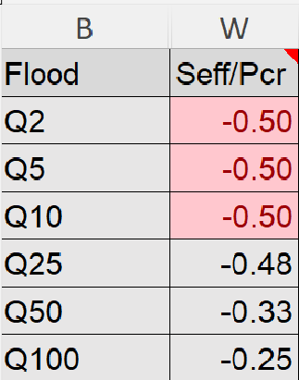

*Note: Limitations reached for Inline at* 10‑year and Crossflow at 25-year return period floods

Figure 7‑3. Pink Errors Exists, Limitations Reached, **FEA Not Required**

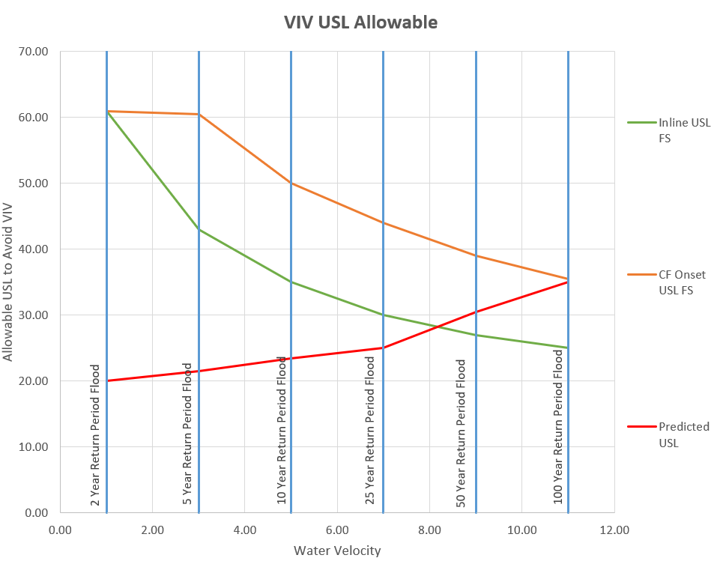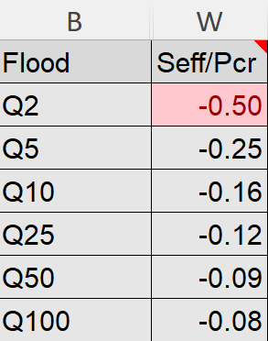

*Note: Limitations reached for Inline at* 38-year and Crossflow at 100-year return period floods

Figure 7‑4. Pink Errors Exists, Limitations Not Reached, **FEA Not Required**

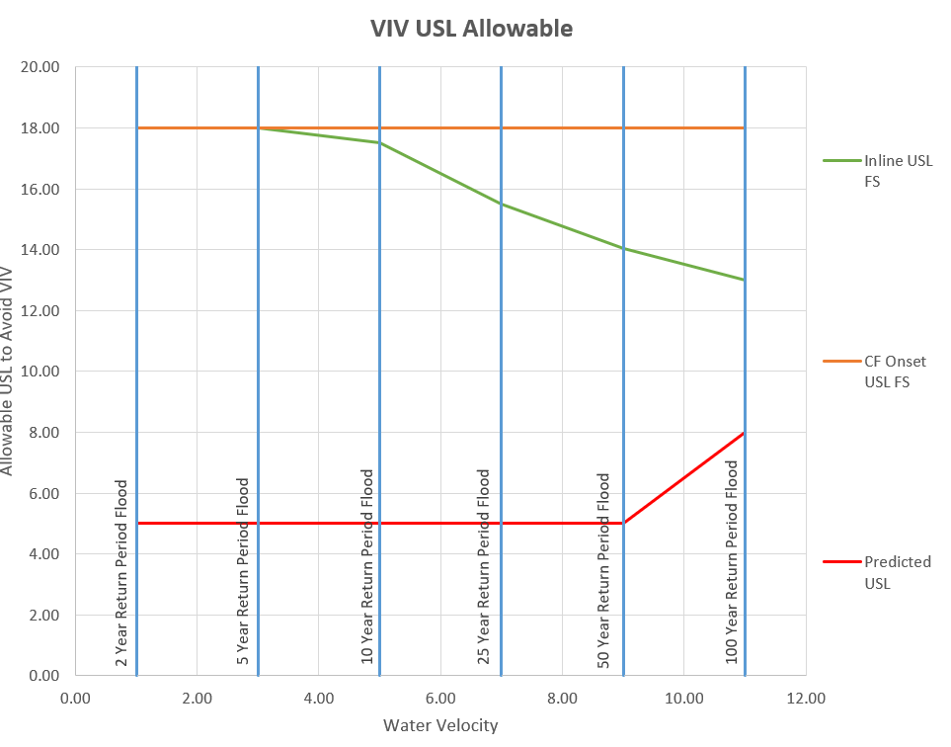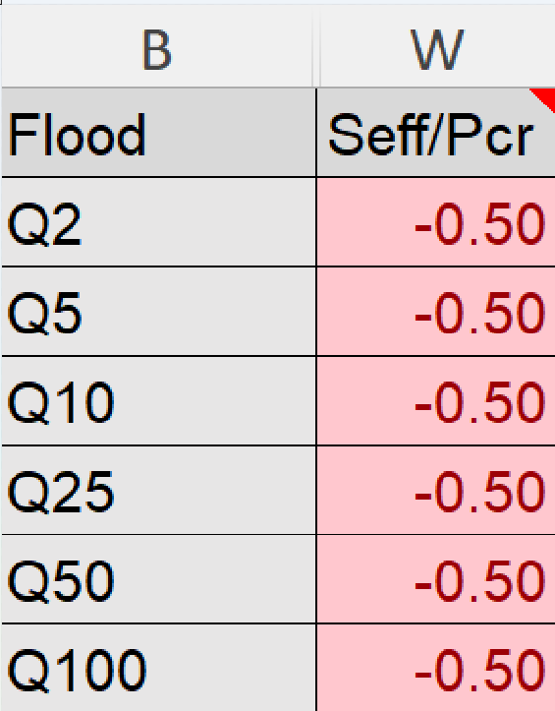

Step 2. Adjust green cells if necessary.

Consider whether concrete coating is providing any additional support. Consider adjusting the blue cell for Free Span Type to “Very well def.” if a professional survey is available; otherwise, use “well def.” if an Operations scope survey is available or any other source such as Light Detection and Ranging (LiDAR) has been used. This input applies a safety factor to the predicted reduced velocity based on the quality of cross section data available; therefore, WCEs can also apply engineering judgement in selecting this value.

Note: If Excel crashes when loading FEA Inputs Macro-Enables Excel, consider running Excel in safe mode. To do so, hold “CTRL” and double click the Excel icon; continue holding “CTRL” until prompted as follows and click “Yes” to continue (see *Figure 7‑5*).

Figure 7‑5. How To Start Excel in Safe Mode

Step 3. Complete the FEA Cross-Section Tool (FEA Inputs) and send to SME for modeling.

A detailed step-by-step procedure on how to complete the FEA Cross-Section Tool (FEA Inputs) is provided in Section 7.2 FEA Cross-Section Tool (FEA Inputs).

Step 4. Receive and review the FEA report.

Upon receipt of the FEA report, it should be reviewed for accuracy. The following items help to confirm quality results:

* Check FEA predicted longest exposed length. This should be close to the values predicted in the “Inputs QAQC” tab or as calculated. Please note the FEA report is generally returned in inches; it measures the length from the pipe center where exposure occurs.
* Inline and crossflow modes listed in the summary results table should be verified that they are in the proper direction. Inline should vibrate in the x-direction; crossflow should vibrate in the y-direction. This can be checked by reviewing the axis of vibration shown in the Mode Images for the respective Modes listed in the Results tables, as shown below on *Figure 7‑6* and *Figure 7‑7*.

|  |  |
| --- | --- |
| Figure 7‑6. Crossflow Direction Verification Example | Figure 7‑7. Inline Direction Verification Example |

* Verify that the frequency listed in the Results table of the report match those listed with the corresponding Mode Image, as shown below on *Figure 7‑8*.

|  |
| --- |
| Figure 7‑8. Frequency Verification Example |

* Verify that the mode shape is realistic, and participation factors make sense on those modes.
* Participation factors indicate the relative amount of vibration in each direction for the various modes. The largest participation factor should be listed in the column corresponding to the primary direction of motion. PFx indicates vibration in the X-direction (inline flow), PFy indicates vibration in the Y-direction (crossflow), and PFz indicates vibration along the pipe. An example table of Participation Factors as they may be presented in the FEA report is shown on *Figure 7‑9*.

Figure 7‑9. Participation Factor Verification Example

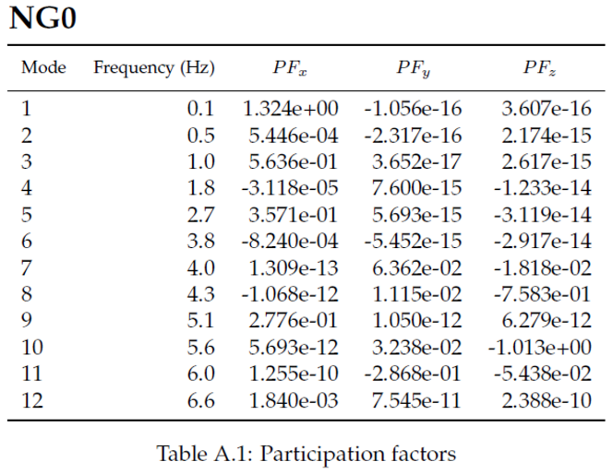

* Mode shapes for the reported mode in the summary table should be verified to make sure there is nothing unusual about the shape and there is not irregularity between the shape and the reported value. For example, a specific segment in the entire span could be subject to velocity of water; therefore, frequency reported on a mode shape that shows the most displacement in that segment should be used. The example below as *Figure 7‑10* shows how mode shape should be used to verify whether the correct mode shape has been reported.
* In the *Figure 7‑10* example, the segment of concern (segment 3) is only subject to water velocity, as the rest of the pipe is parallel to the flow. To determine the dominate mode and frequency for this span, the SME used the maximum modal deflection at mid-span from the first twelve mode. The mode is selected by the lowest mode in which the mid-span deflection is greater than 0.9 or, if not, the mode with the greatest mid-span deflection.
* In examplefor Mode 1 (*Figure 7‑11)*, it can be seen that the displacement is in a different segment and not in the segment of concern. The graph in *Figure 7‑12* shows the displacement at mid-span for exposed segment 3; it can be seen that in ‘Ux’ direction at Mode 1, the displacement is not enough, whereas the displacement in segment 4 for Mode 1 (*Figure 7‑13*) shows a value greater than 0.9.
* Similarly, *Figure 7‑14* above shows displacement in segment 3; and it can also be concluded from the table for segment 3 (*Figure 7‑12*) that Mode 4 shows the midspan displacement value higher than 0.9. Therefore, the value should be verified in the frequencies reported in the summary table that it makes sense and is representative of the case.
* The modeled frequency should generally (but may not always) fall between the pin-pin and fix-fix analytical values. Engineering judgement should be used when evaluating FEA natural frequency compared to boundary conditions. Two examples are listed below. If FEA natural frequency lands outside of anticipated range, then discuss with the SME.
  + Sometimes, such as with weak soils, boundary conditions will behave closer to pins and the modeled frequency may fall closer to or just outside of the pin-pin analytical frequency.
  + A pipe span that is embedded in stiff soil on one end (similar to a fixed support) and is supported on a vertical pipe support without horizontal constraint at the other end (similar to a pin) would likely have a modeled frequency somewhere between that of the fix-fix and pin-pin analytical values.

Figure 7‑10. Mode Shape Verification Example

Segment of interest

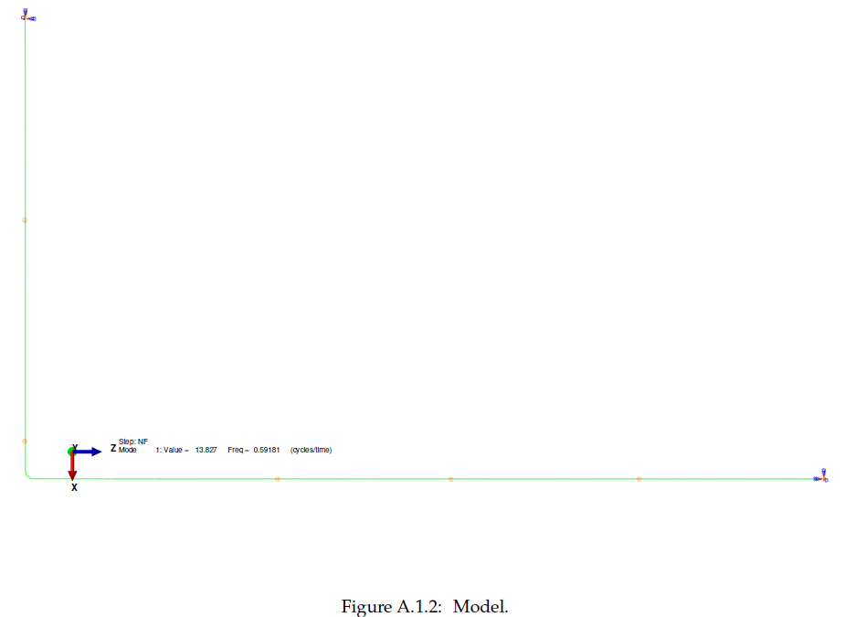

Segment of interest

Figure 7‑11. Mode Shape Verification Example, continued

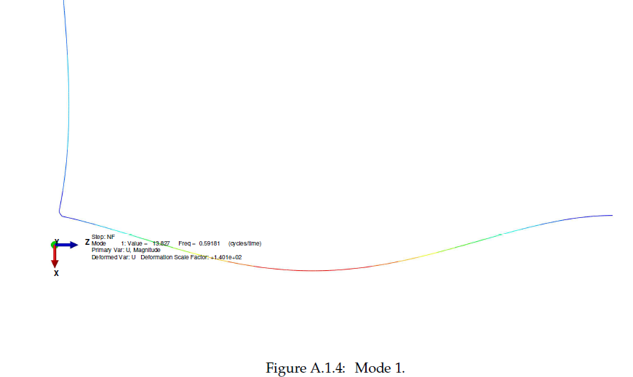

Mode 1

|  |  |
| --- | --- |
| Figure 7‑12. Displacements at mid-span for exposed segment 3  Displacements at mid-span for exposed segment 3 | Figure 7‑13. Displacements at mid-span for exposed segment 4  Displacements at mid-span for exposed segment 4 |

Figure 7‑14. Mode Shape Verification Example, continued

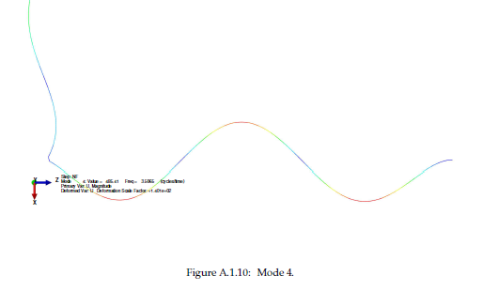

Mode 4

Discuss any discrepancies with the SME/FEA contractor as needed. If FEA inputs need to be updated, update the FEA Input file and provide it to the FEA contractor to re-run the analysis. If the inputs are good, they may be input into the VIV Template in orange cells in rows 52 through 121. Be sure to verify the velocity used for duration graphs in blue cell W1.

Step 5. Complete the “Protocol” Tab of the VIV Template tool.

Select Yes for the question asking, “Pipe has supports, a significant bend, is steep (>15º), or has other VIV related issue that requires SME?” This should always be “Yes” if FEA was used.

**Step 6. Copy the relevant orange cells and paste them into the Protocol “Data Input” tab.**

## FEA Cross-Section Tool (FEA Inputs)

The FEA Cross-Section Tool (FEA Inputs) includes three initial tabs: Instructions, Crossing Info (general inputs), and Natural Ground (NG) (the cross-section geometry); see *Figure 7‑15*. The crossing data should be filled in to match the WCP Protocol and VIV Template tool. Cells filled in black are not necessary to fill out. The erosion rates should match the outputs from the RSST; however, for most pipeline crossings, the pipe-bank angle should be similar to the angle of attack of water on the pipeline. If erosion rate was not calculated from RSST, but rather by overlaying past surveys, then enter “90 deg” in the pipe-bank angle field, as erosion rate is already provided along the pipeline. Pipe-bank angle is only needed to convert the erosion rate from the RSST (taken perpendicular to the channel) to a rate measured along the pipeline. If no erosion is predicted, use “0” (zero) as the erosion rate. This implies that there is no change of channel and pipeline USL for a duration scenario and only one cross section could be considered for FEA analysis.

Figure 7‑15. Initial tabs of FEA Cross-Section Tool (FEA Inputs)



**Step 1. Inputs for “NG” tab**

The geometry of the crossing should be input in the “NG” tab. Generally, columns A, B, C, and D should match the Phase III RSST cross section inputs. One exception is if the pipeline has an angle of attack (that is, the pipeline is not oriented perpendicular to the direction of flow in the channel). While the cross section entered in Phase III of RSST is taken perpendicular to the cross section in order to properly calculate drag force, the stationing and coordinates of the cross section entered in the VIV FEA Cross Section tool should be taken ***along*** the pipeline. Columns F and G may require adjusting to reflect whether the pipe has any variation in straightness. It is recommended that an Excel graph is overlaid on a screenshot of the plan view of the survey for crossings with variations in straightness.

For straight pipelines (straight line on the plan view), the x-axis can be assumed along the pipeline; therefore, “x_Coordinate” (column F) matches the “Distance from Left Edge of Cross Section” (column A). The y-axis will be perpendicular to the x-axis and since pipeline is straight; “y_Coordinate” (column G) should be considered as a constant arbitrary value. *Figure 7‑16* shows an example of this scenario.

For non-straight pipelines, the “x_coordinate” (column F) and “Distance from Left Edge of Cross Section” (column A) are likely not the same and “y_coordinates” will vary. The x-axis can be assumed in any direction but will not always be along the pipe stationing. *Figure 7‑17* shows non-straight pipeline with the x-axis assumed along the pipeline for the first straight portion of the pipeline; for this example, the x coordinates and pipeline stationing are the same and y coordinates remain unchanged until deviation of the x-axis from pipeline stationing starts. From that point, the distance along pipeline stationing can be converted into x and y coordinates using the Pythagorean Theorem as follows (*Equation 7‑1)*:

|  |  |  |
| --- | --- | --- |
|  | $${\left(distance between pipeline stationing\right)}^{2}= {∆x}^{2}+ {∆y}^{2}$$ | *Equation 7‑1* |

|  |  |
| --- | --- |
| Figure 7‑16. X and Y Coordinates for Straight Pipelines  x and y coordinates for straight pipelines  *Note: the angle of attack does not affect the x and y coordinates as long as the x-axis is assumed along the pipeline stationing. The y coordinates are constant and can be assumed any arbitrary value.* | Figure 7‑17. X and Y Coordinates for Non-Straight Pipelines  x and y coordinates for non-straight pipelines  *The x-axis will not always remain along the pipeline stationing. The distance along the pipeline can be broken into x and y components.* |

Locate any supports within the cross section. Mark the proper station by changing column J (“Support”) to “Yes”. If the support is horizontally restrained with a U-bolt or guide, then set column K (“Direction”) to “Both”; if not, then set column K to “Vertical”.

Tips:

* Make sure no additional data are at the bottom of the cross section. The template file may be prefilled for example purposes. If the cross section is shorter than the example, then remove example data at the bottom.
* Make sure left flood plain is first and right flood plain is last. Make sure spelling and capitalization are correct in column C.
* Include at least one channel high bank to high bank width of pipe cover in each bank where practical. For pipes that do not become buried, include sufficient length in either direction and choose a point to end the model, putting support in both vertical and horizontal directions to represent a pin-pin boundary.
* Perfectly straight pipes often show buckling response when temperature is applied. Including any slight variation in straightness may help the model run smoothly.
* Distance from Left Edge of Cross Section may not match the x_Coordinate.
* Make sure the span lengths (from support-to-bank or support-to-support) match the survey. This can be checked by subtracting stations (column A) between supports or supports and bank.
* Check for any unnecessary supports. When column J is marked with a “Yes”, the cell will turn green.
* Make sure all supports include a direction.
* Make sure that where a formula has been applied to columns cells, it has been copied on all cells in that column where cross-section points exist. After the macro is run, sometimes the tool will create a cell but not copy the formula, which can cause errors in the cross section.

Step 2. Run the Duration Tool Macro.

The duration tool estimates bank erosion for the 5-year, 10-year, and 20-year return period flood duration assuming consistent bank erosion. The tool converts the existing survey (“NG”) into a format used by the FEA SME by removing column C from the inputs. Finally, it also includes a “QAQC” tab and “Duration Graph” used to check whether outputs from the tool make sense (see *Figure 7‑18*).

If bank erosion is not applicable to the crossing, the outputs for “5yr”, “10yr”, and “20yr” can be deleted.

If multiple runs are required (e.g., for a second scenario where a pipe support becomes restrained), the initial geometry inputs can be changed and the tool run again. The tool output will include similar tabs, but with a new revision number.

Figure 7‑18. Scenario 0 may be existing supports, Scenario 1 may be with restraints



Step 3. Import event-based scour cross sections from RSST.

If scour causes increased span length, scoured cross sections can be taken from the RSST tool. Start by copying the “NG” input tab from the duration tool run and rename it after the event that causes an increase in USL (e.g., “Q100” for a 100-year return period flood). In the RSST, unhide the tab for “Cross Section Variation Q100” or flood event as necessary. Column CZ includes the final scoured cross section ground elevation (see *Figure 7‑19*). This value can be copied into the FEA Inputs sheet tab (see *Figure 7‑20*) for this flood (tab Q100 in this example). Delete column C (“C/FL”) from this tab. Repeat this step for any applicable flood events up to and including Q2, Q5, Q10, Q25, Q50, and Q100.

Figure 7‑19. Scoured Cross Section in RSST

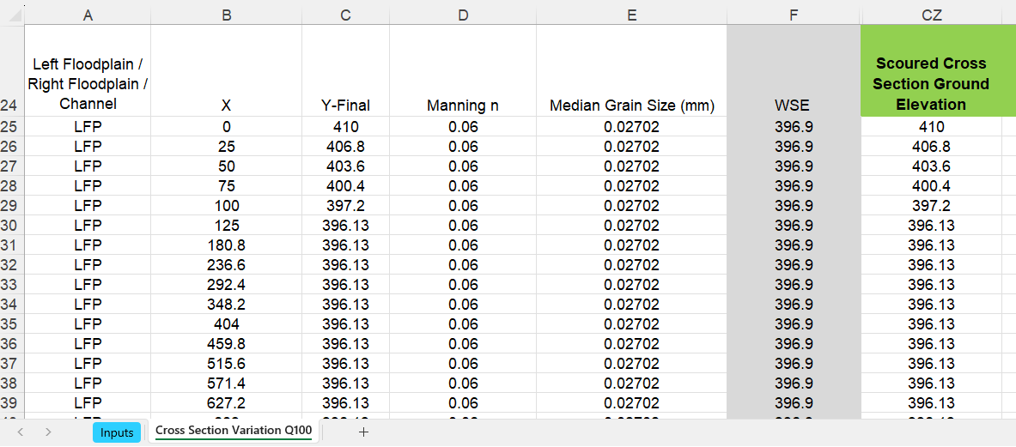

Figure 7‑20. Final FEA Inputs Columns

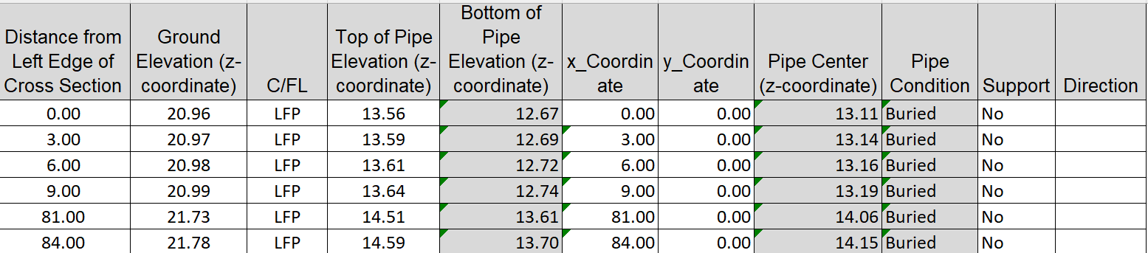

Step 4. Discuss alternate FEA input scenarios.

It is recommended that if risk is likely at the crossing and pipe supports already exist or could be installed, that the WCE and a mitigation coordinator discuss alternate scenarios to be included in the FEA Inputs. For example, crossings with vertical support, if risk is possible, include scenarios where the restraints are made in both the vertical and horizontal directions. If running the model to test for exceedances in pipeline limitations for the current conditions, normal operating pressure (NOP) must be used. When verifying the sufficiency of mitigation scenarios, maximum operating pressure (MOP) should be used.

Step 5. Perform quality control on the populated FEA Cross Section tool with another WCE.

The quality assurance and quality control (QAQC) engineer should reference the VIV Job Loss Analysis Job Step #3 for a list of specific items to look for and discuss with the WCE.

Step 6. Save a copy to submit to the FEA SME.

Use Save As to save a copy of the FEA Inputs as a regular Excel Worksheet without macros. Once the copy is saved, delete the following tabs:

* Instructions
* NG (Geometry inputs)
* QAQC (may be several scenarios)
* Duration Graph (may be several scenarios).

Save the copy and submit it to the lead WCE or/and WCP execution lead for review or/and QAQC. After review/QAQC is completed, it will be submitted to the FEA SME for modeling.

## WCP Protocol

The “Data Input” tab of the WCP Protocol tool includes the same question about needing FEA performed as the VIV Template tool, “FEA Needed? i.e. Pipe is suspended AND either: has supports, a significant bend, is steep (>15º), or has other VIV related issue that requires SME?” The answer here should be the same as the VIV Template tool and will affect which inputs can be copied and pasted into the WCP Protocol tool.

Pending the answer, portions of rows 129 through 144 of the “Data Input” tab may change formatting to indicate which values need to be copied.

For WCP Protocol with results from analytical equation, USL graphs can be used. For the Form 5.1 Event USL, inline and crossflow VIV lines should be presented. For the Form 5.1 Duration Graph, only crossflow VIV should be shown if it is applicable. If the predicted span exceeds the allowable USL for inline or crossflow VIV, then the crossing should be risk assessed. If either is drafted as highlighted risk, it is recommended that the crossing be re-evaluated with FEA results.

If FEA is used, the Form 5.1 Event USL and Duration USL Graphs should not include any lines for VIV and values for allowable USL for VIV should be set to “NA”. Instead, the Form 5.1 Event Vr and Form 5.1 Duration Vr graphs should be used. For the reduced velocity graphs, compare solid red (predicted inline reduced velocity) to solid black (allowable inline reduced velocity) and dashed red (predicted crossflow reduced velocity) to dashed black (allowable crossflow reduced velocity). If the predicted reduced velocity exceeds the allowable reduced velocity for inline or crossflow VIV, then the crossing should be risk assessed. See *Figure 7‑21*.

Figure 7‑21. Reduced Velocity -Event Graph

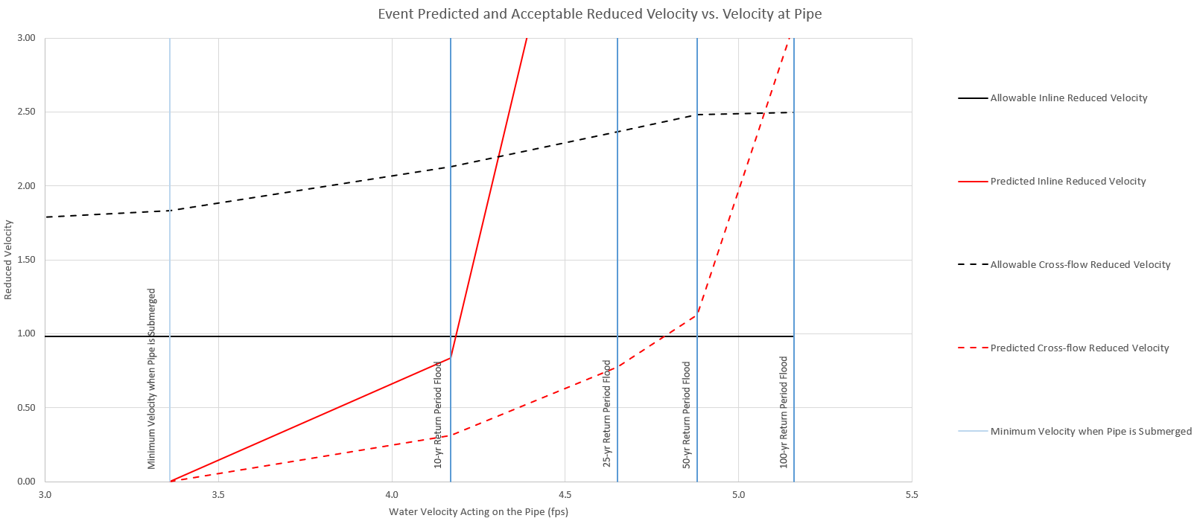

Note: Predicted Inline Vr Exceeds at 11-Year Flood Event; Predicted Crossflow Vr Exceeds at 80-Year Flood Event

# Risk Assessment Inputs

The Risk Assessment Guidelines are discussed in *Appendix J* of *WCP* [*Technical User Guide*](https://teamwork4.exxonmobil.com/sites/GlobalWCP/Shared%20Documents/WCP%20Toolkit/WCP%20%20Manuals%20and%20Guidelines/WCP%20Technical%20User%20Guide)*.*

The following data are needed to perform risk assessments:

* What storm event is predicted to reach limitations for inline and/or crossflow VIV?
* Is there any uncertainty that the pipe may become fully submerged or that a gap will scour below the pipe to allow water flow on both sides?
* For inline VIV scenario, is the crossing greater than 75 feet wide from high bank to high bank or is the slope greater than 10%?
* What additional barriers need to be accounted for (e.g., flood plain scour)?

For the crossing when there are multiple pipelines in closed proximity it is recommended to consult with VIV SME to discuss on how to accommodate the shielding effect during the risk assessment (*Figure 8‑1*).

Figure 8‑1. Multiple Pipelines on Pipe Supports – Shielding Case

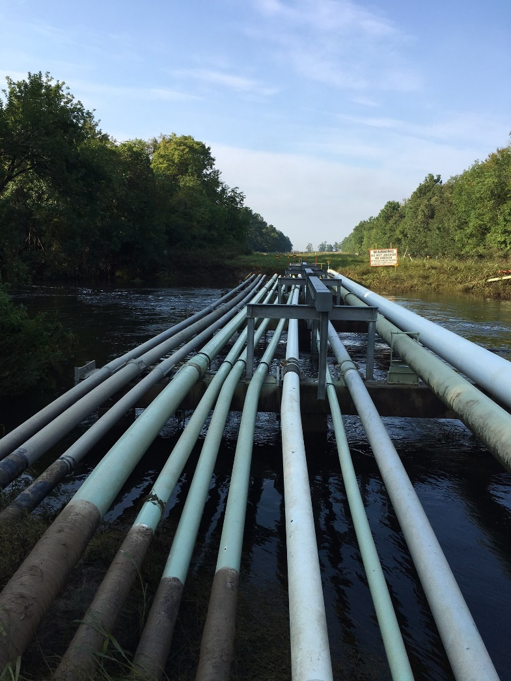

# Mitigation Options

Multiple options may be available to mitigate VIV threats:

* Relocate the pipeline (including horizontal directional drilling and open cut methods) to remove the pipeline from the water crossing threat
* Adjust existing supports such as horizontal restraints or cantilevering additional support
* Add supports. The FEA reports may indicate the best position to place a new support. The deflected mode shapes indicate the maximum deflection in red. Providing a support at these locations will provide the greatest benefit
* Case the pipe to increase the diameter of the crossing and increase the internal resistance to vibration
* Pressure and soil sensitivity.

Mitigation options design/selection is usually led by XOM Site Project Engineer. When available/possible WCEs should include the mitigation scenarios, while running FEA for an existing condition to reduce costs on FEA analysis. A possible example could be to add an additional scenario along with the NG scenario where the support direction can be changed to ‘both’ if it is only supported ‘vertically’ or ‘horizontally’ for the base case. This scenario will capture the mitigation for adding restraints; if restraints will mitigate the threat, then additional FEA analysis may not be required. See example on *Figure 9‑1*.

Figure 9‑1. Horizontally Unrestrained Pipelines on Pipe Supports

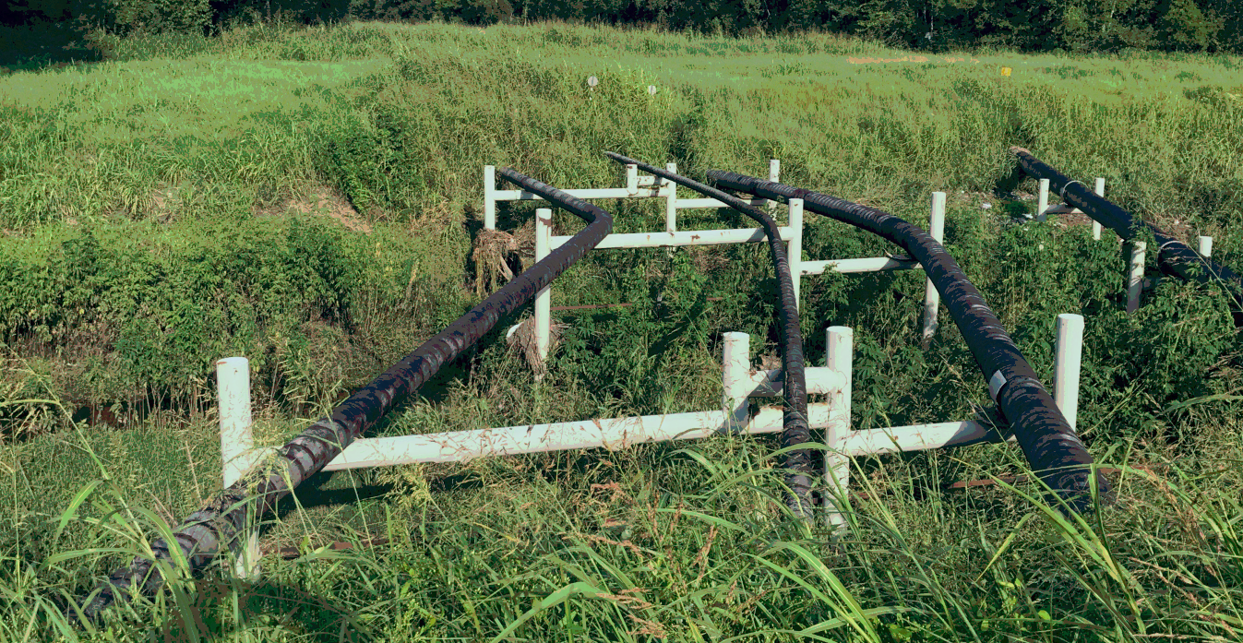

Note is that the mitigation designs are evaluated for MAOP and, since NG scenarios are assessed at NOP, a ‘pressure vs. frequency’ plot can be obtained for the mitigation scenarios if the mitigation and base case scenarios are assessed together (see *Figure 9‑2*).

Figure 9‑2. Pressure vs. Frequency Plot Example

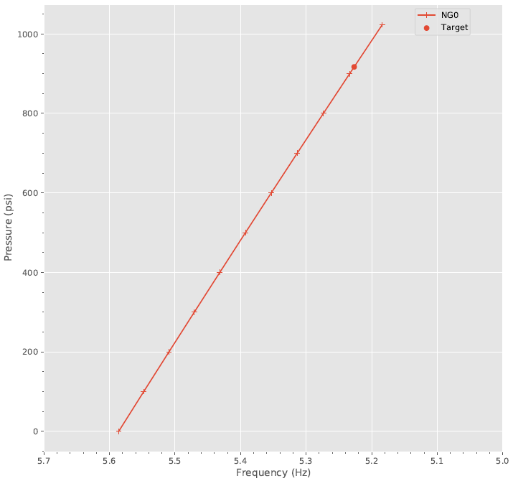

If the natural frequency of the pipeline is very close to the allowable frequency, a pressure sensitivity analysis should also be performed to gain more understanding of the pressure at which VIV would be deemed a non-credible threat (i.e., having no credible potential for compromising pipeline integrity). This could help with potentially avoiding a mitigation measure; instead, Operations could implement pressure reduction controls at the flood event where VIV is predicted to be exceeded. This is usually the case with crossflow VIV, as inline VIV usually results in a lower risk category that does not warrant a mitigation. If crossflow VIV threat can be eliminated by pressure reduction, then Operations should be made aware of the pressure threshold value to determine whether it is realistic, and then additional control measures should be discussed during the risk assessment meeting and documented.

Another method to potentially eliminate VIV is by requesting a professional survey for verification purposes if the original assessment where VIV was exceeded was performed as an Operations scope survey. Operations scope surveys used in VIV assessment could apply a safety factor. VIV assessment performed based on professional surveys do not apply any safety factor. If the VIV exceedance is sensitive to this criteria, and after removing the safety factor using the professional survey for the analysis could result in elimination of the VIV (usually crossflow VIV), then a professional survey should be requested. Another benefit is that professional surveys usually provide better soil data. If the WCE suspects that stiffer soil is present based onsite photographs, then a geotechnical SME should be consulted for further confirmation and a stiffer soil input should be used to remove any conservatism in the analysis.

Tip: If the WCE suspects that soil data is sensitive to VIV results and could result in non-credible data with stiffer soil inputs, then the surveyor should be asked to provide good soil data.

Acronyms and Abbreviations

API American Petroleum Institute

ASME American Society of Mechanical Engineers

CAT Category

CSF Concrete Stiffness Factor

DNV Det Norske Veritas Company

DOC Depth of Cover

EDD Equipment Degradation Document

FEA Finite Element Analysis

GMOP Global Manufacturing OIMS Practice

HC Higher Consequence

HWAP High Water Action Plan

KC Kuegler-Carpenter

LiDAR Light Detection and Ranging

MAOP Maximum Allowable Operating Pressure

MOP Maximum Operating Pressure

NG Natural Ground

NOP Normal Operating Pressure

OD Outside Diameter

OIMS Operations Integrity Management System

QA/QC Quality Assurance/Quality Control

RSST Rapid Scour Screening Tool

SBRA Scenario Based Risk Assessment

SSHE Safety, Security, Health, and Environment

SME Subject Matter Expert

SMYS Specified Minimum Yield Strength

USL Unsupported Span Length

VIV Vortex-Induced Vibration

Vr Reduced Velocity

WCE Water Crossing Engineer

WCP Water Crossing Program

w.t. Wall Thickness

XOM ExxonMobil Corporation

External References

*[1]* API (2017). Managing Hydrotechnical Hazards for Pipelines Located Onshore or Within Coastal Zone Areas, American Petroleum Institute API RP 1133 2nd edition 2017.

*[2]* ASME (2002). Pipeline Transportation Systems for Liquid Hydrocarbons and Other Liquids. ASME B31.4-2002. American Society of Mechanical Engineers (ASME), 2022.

*[3]* ASME (2022). Pipeline Transportation Systems for Liquids and Slurries. ASME B31.4-2022. American Society of Mechanical Engineers (ASME), 2022.

*[4]* DNV (2021). Det Norske Veritas Recommended Practice F-105 Free Spanning Pipelines (DNV-RP-F105). Det Norske Veritas, Edition June 2017, amended September 2021.

*[5]* Google (2025). Google Weather averages, Available online at: [*https://www.google.com/*](https://www.google.com/)*.* Accessed March 2025.

*[6]* US Climate Data (2025). Available online at: [*USClimateData.com*](https://www.usclimatedata.com/). Accessed March 2025.